1. **Executive summary**

There is uncertainty surrounding the usage of resources at Eppley. An important factor that needs to be taken into consideration given the uncertainty of demand of equipments is the utilization strategy.

Optimum resource utilization can be highly beneficial and one method of developing utilization strategies is to use simulation modeling to create best case scenarios. Simulation models enable the user to visualize how tweaking various parameters can alter an entire system. A sport or recreation entity must also have maximize resource utilization in order to maintain customer satisfaction and profitability.

Recreational center of University of Maryland needs a better understanding of the usage of their resources(equipments) in order to facilitate resource utilization and better queue statistics. In this project, we have simulated the system to support decision-making to place optimal number of resources based on the behavior of the system.

1. **Conceptual model**

Our goal is to improve resource utilization and reduce queue lengths and times. Our model takes into account customer arrivals, preference of gym section-cardio or weightlifting, as well as equipment assigned.

When a customer enters Eppley, they can choose between cardio section and weightlifting section after swiping their ID. After choosing their preference of workout, customer can proceed to decide between different equipments within a section. This can be followed by the customer’s decision to stay and perform the alternative workout or exit the facility. The output measures of interest in the simulation modeling are-resource utilization and queue statistics.

**I.** **Model Implementation in Arena**

**1.** **Overview**

There are 23 modules which include 6 types- Create, Process, Decide, Assign, Record and Dispose.

**2.** **Logic Flow**

**(i) Arrival process**

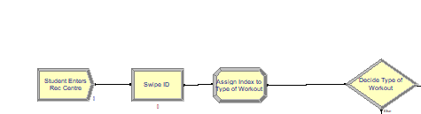

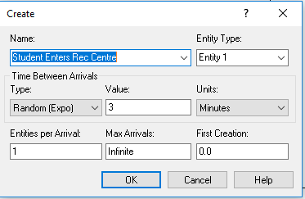

Customers enter at the interarrival rate of EXPO~(3 mins). After swiping their ID, the type of workout(pc index) will be randomly assigned.

**(ii) Decision between Cardio and Weightlifting section and between gym equipments within each section**

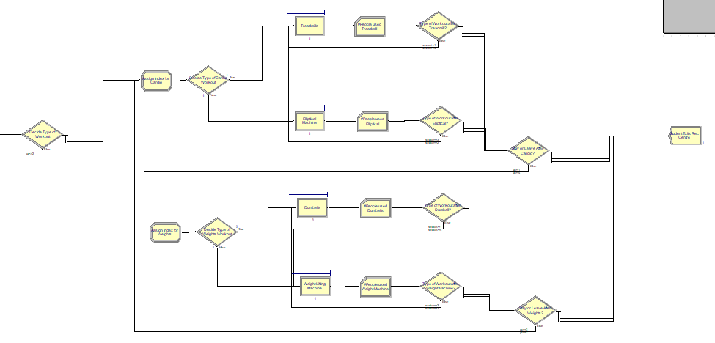

The customer is faced with the decision of workout between-cardio and weights section. The customer will be randomly assigned as index. If pc index<=2, the customer will go to the cardio section irrespective of the next decision.

**Decide Type of Workout**

|  |  |
| --- | --- |
| **Pc** | **Action** |
| **<=2** | **Go to cardio workout** |
| **Else** | **Go to weights workout** |

**Cardio workout section**

The customer faces the decision of treadmill and elliptical in the cardio section. An index will randomly assigned within the cardio section. If nchoice index<=2, the customer uses treadmill irrespective of the next decision.

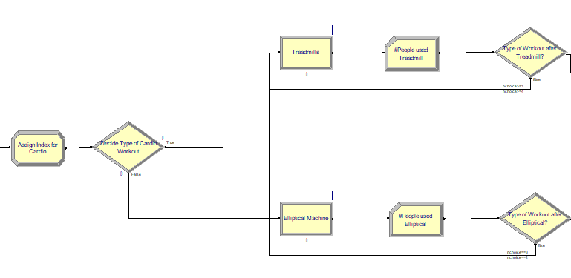

Based on the index Nchoice-

**Decide Type of Cardio Workout**

|  |  |
| --- | --- |
| **Nchoice** | **Action** |
| **<=2** | **Go to treadmill** |
| **Else** | **Go to elliptical machine** |

The next decision after using treadmill is deciding whether to leave after using treadmill or proceeding to do elliptical within the cardio section. Similarly, the next decision after using elliptical is whether to leave after using elliptical or using the treadmill before leaving the cardio section.

**Type of Workout after Treadmill?**

|  |  |
| --- | --- |
| **Nchoice** | **Action** |
| **>=1** | **Use only treadmill and exit** |
| **>=4** | **Use treadmill and then elliptical and, exit** |

**Type of workout after Elliptical?**

|  |  |
| --- | --- |
| **Nchoice** | **Action** |
| **=3** | **Use only elliptical and exit** |
| **=2** | **Use elliptical and then use treadmill and, exit** |

**Weights workout decision**

The customer faces the decision of dumbbell and weightlifting machine in the weights section. An index will randomly be assigned in the weights workout section. If nchoice<=2, the customer uses dumbbells irrespective of the next decision.

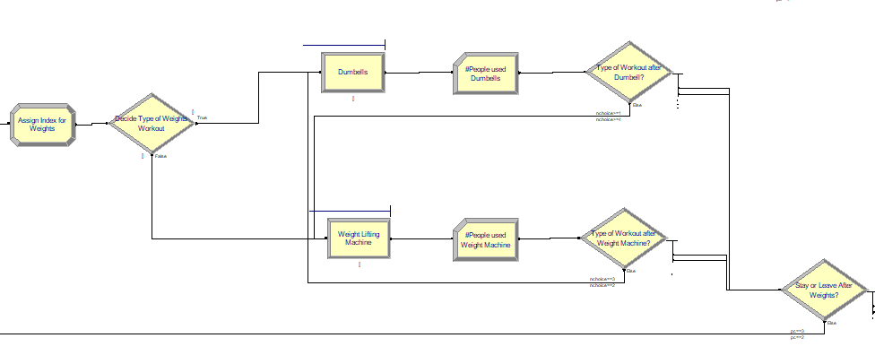

Based on the index Nchoice-

**Decide Type of Weights Workout**

|  |  |
| --- | --- |
| **Nchoice** | **Action** |
| **<=2** | **Go to dumbbells** |
| **Else** | **Go to weightlifting machine** |

The next decision after using dumbbell is deciding whether to leave after using dumbbell or proceeding to use weightlifting machine within the weights section. Similarly, the next decision after using weightlifting machine is whether to leave after using the machine or using the dumbbell before leaving the weights section.

**Type of Workout after Dumbbell?**

|  |  |
| --- | --- |
| **Nchoice** | **Action** |
| **>=1** | **Use only dumbbells and exit** |
| **>=4** | **Use weightlifting machine and then use dumbbells and, exit** |

**Type of Workout after Weightlifting machine?**

|  |  |
| --- | --- |
| **Nchoice** | **Action** |
| **=3** | **Use only weightlifting machine and exit** |
| **=2** | **Use weightlifting machine and then use dumbbells and, exit** |

After the workout, the customer is faced with the decision to stay or leave the facility.

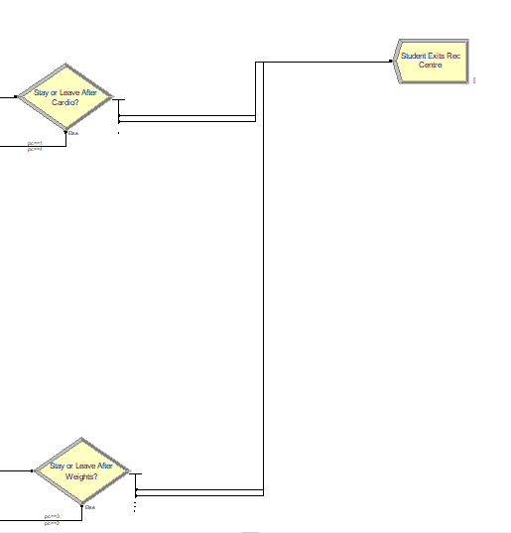

Based on pc index-

**Stay or leave after cardio?**

|  |  |
| --- | --- |
| **Pc** | **Action** |
| **=1** | **Go to only cardio section and exit** |
| **=4** | **Go to cardio section and then go to weights and, exit** |

**Stay or leave after weights?**

|  |  |
| --- | --- |
| **Pc** | **Action** |
| **=3** | **Go to only weights section and exit** |
| **=2** | **Go to weights section and then go to cardio and, exit** |

1. **Input Analysis**

The input data of this model can be categorized into 3 types:

Arrival Time of students queuing delay.

The Arrival Time of students is calculated based on the entrance of people to

the recreational center. Due to the unavailability of the exact data, some

input parameters are estimated based on empirical

observations while others are cited from trustworthy data sources.

We tried to make those estimations close to reality in order to test feasibility

of our model. As long as real data is available, our model can be adjusted

flexibly and easily for general use.

1. Arrival Time

In order to acquire practical data, we take Eppley data of student entry which we

received from Christopher.

Exponential distribution to simulate the arrival rate.The originally plan is to simulate

the behavior for the entire period of January till now.

The preliminary result is shown in below chart.

The distribution is exponential having the expression 1.5 + EXPO(0) with a squared

error 0.019143. We have created a histogram with 15 intervals having a range of

1.5 to 22.5. We have applied the chi square test having 7 intervals.

The degree of freedom is 5 and test statistic is 19.

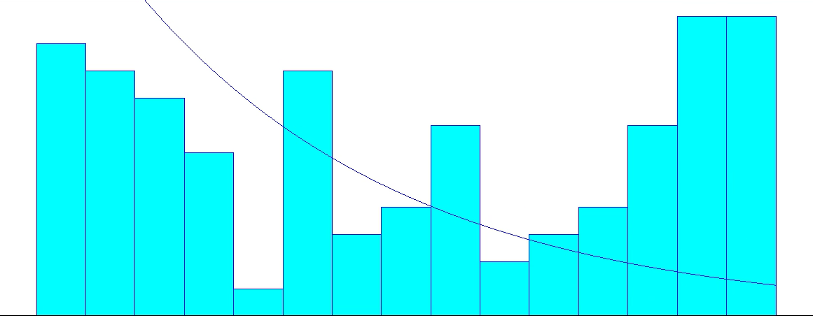

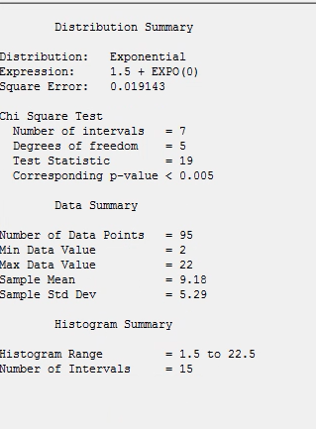

**Empirical estimation of parameters based on:**

We obtained information for various sources to conduct a simulation on the existing system of the rec center. We contacted Christopher J Topping the assistant director of ERC and Satellite Facilities who provided us with the total number of people who enter Eppley everyday. We have used the data from Jan 2019 till date.

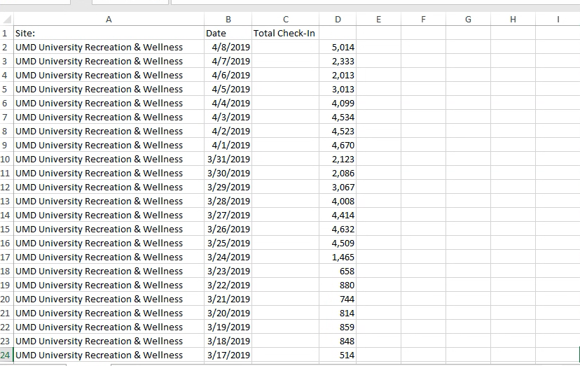

We also contacted Tami Lee, the Assistant Director for Fitness who gave us the exact statistic of equipment available in Eppley which we incorporated in our model. Since we were mainly concentrating on the gym and weights part of eppley we created a google form and distributed it among our peers to find where they faced the maximum queues.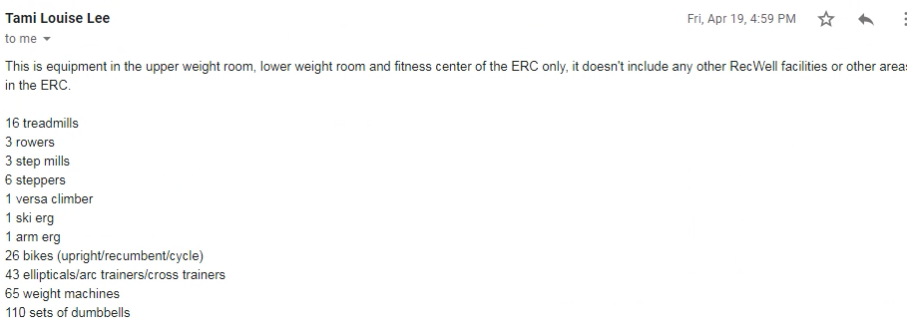

We also created a google form and sent it to our peers to get real time data and statistics. We found that a greater number of people visit eppley over the weekend and also find larger queues then.

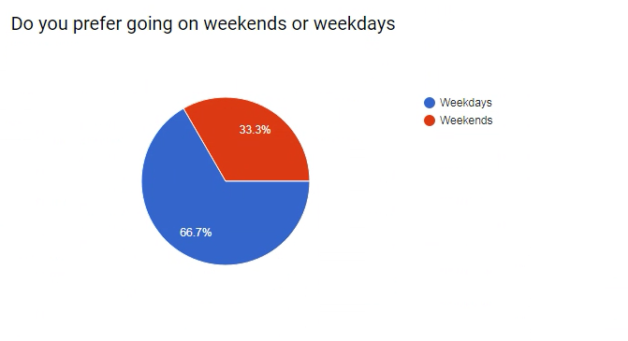

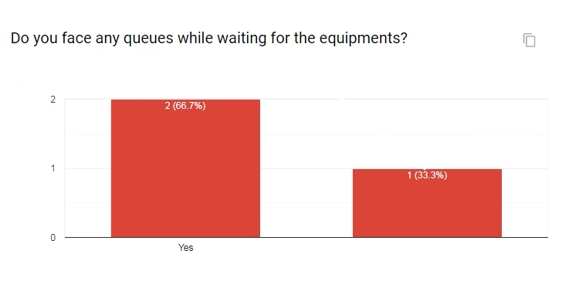

Estimates of parameters is taken using the above data and have tried to be

maintained as accurately to real time data as possible.

1. **Performance analysis**
2. **Output analysis**
3. **Simulation experiments**
4. **System improvement**